Unified Messaging

FAQ

What is Unified Messaging?

Unified Messaging is the integration of voicemail and email into one interface. In this case, your email and office voicemail will all be stored in your Microsoft Outlook inbox.

What does this mean to me?

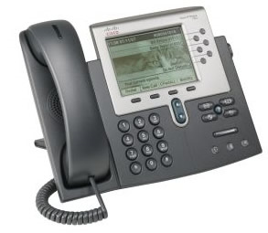
In the past, when you received a voicemail, your phone’s indicator light would light up red, indicating that new message.

With unified communications, you will also receive an email with a .wav file attachment of that message. It will arrive as an unread message
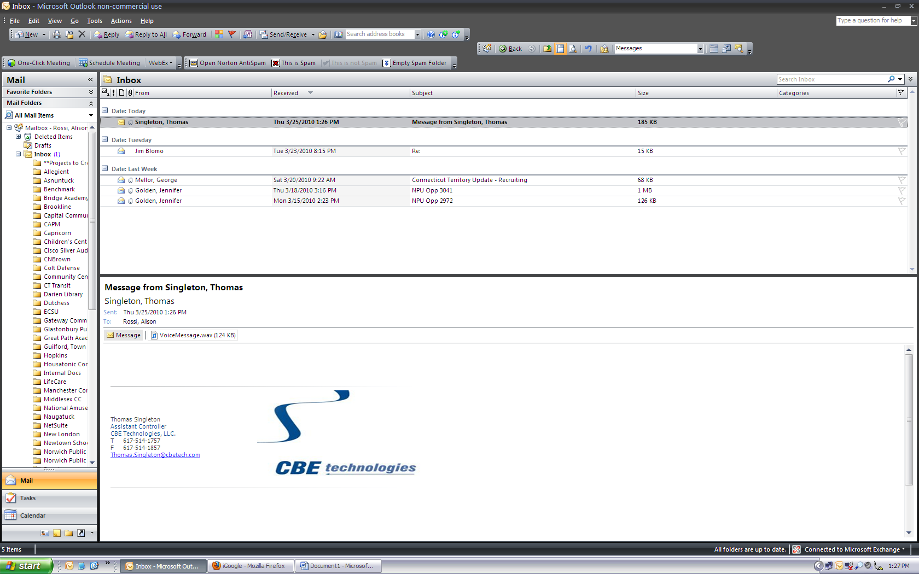

You can check the voicemail message in either location. Once you have checked the message, it will show up as “read” in your email and your phone’s indicator light will not be red any longer.

Will I lose my old voicemail?

No, once this new system goes live, your current saved voicemail will show up in your email as unread messages.

Unified Messaging Common Tasks

Listening to a message on the computer

When a voicemail message shows up in your inbox, the .wav file will be attached to the email message. Your computer must be equipped with either internal or external speakers to listen to the message.

To open the message, double click on the .wav attachment. Your default media player will begin to play the message.

If you are unable to hear the message, begin troubleshooting by making sure that your computers volume is not on mute. If you are using external speakers, make sure that they are on and functioning.

Deleting a voicemail message from your inbox

To delete a message from your inbox, simply highlight the email and click the delete key on the keyboard. In addition, you can click the delete button on the Outlook task bar or press Ctrl + D.
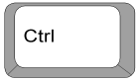
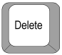
OR +

*Note – if an item is deleted from the inbox, it is also deleted from the phone. In addition, if a voicemail is deleted from the phone, it will no longer show up in email. *

Forwarding messages to someone else
Since the .wav files are simply attachments to the email itself, you can forward the voicemail to another user’s email address by clicking the Forward button the toolbar when the email is highlighted.

Saving your messages to your computer

To save the .wav file to your computer, begin by double clicking on the .wav attachment.

When the dialogue box appears, choose the save option.
Choose the desired location to save your file.
*Optional: users can rename the file for easier access*

